Question 129 ( Single Topic )

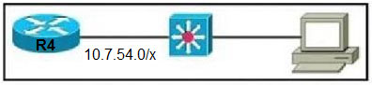  
Refer to the exhibit. The router has been configured with a super net to accommodate the requirements for 380 users on a Subnet. The requirement already considers 30% future growth. Which configuration verifies the IP subnet on router R4?

* **A.**Subnet: 10.7.54.0 Subnet mask: 255.255.128.0 Broadcast address: 10.5.55.255 Usable IP address range: 10.7.54.1 ג€" 10.7.55.254
* **B.**Subnet: 10.7.54.0 Subnet mask: 255.255.255.0 Broadcast address: 10.7.54.255 Usable IP address range: 10.7.54.1 ג€" 10.7.55.254
* **C.**Subnet: 10.7.54.0 Subnet mask: 255.255.254.0 Broadcast address: 10.7.54.255 Usable IP address range: 10.7.54.1 ג€" 10.7.55.254
* **D.**Subnet: 10.7.54.0 Subnet mask: 255.255.254.0 Broadcast address: 10.7.55.255 Usable IP address range: 10.7.54.1 ג€" 10.7.55.254

##### Question 131 ( Single Topic )

DRAG DROP -  
Drag and drop the IPv6 address type characteristics from the left to the right.  
Select and Place:

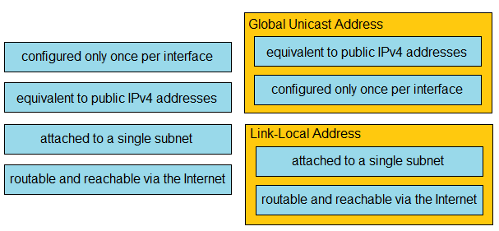

Question 133 ( Single Topic )

How is RFC 1918 addressing used in a network?

* **A.**They are used to access the Internet from the internal network without conversion.
* **B.**They are used in place of public addresses for Increased security.
* **C.**They are used with NAT to preserve public IPv4 addresses.
* **D.**They are used by Internet Service Providers to route over the Internet.

Answer : **C**

##### Question 134 ( Single Topic )

DRAG DROP -  
Drag and drop the IPv6 address types from the left onto their descriptions on the right.  
Select and Place:

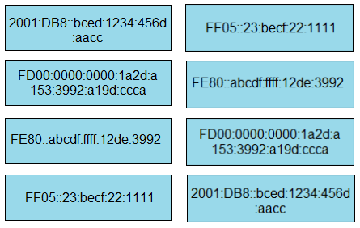

##### Question 136 ( Single Topic )

DRAG DROP -  
Drag and drop the IPv6 address descriptions from the left onto the IPv6 address types on the right. Not all options are used.  
Select and Place:

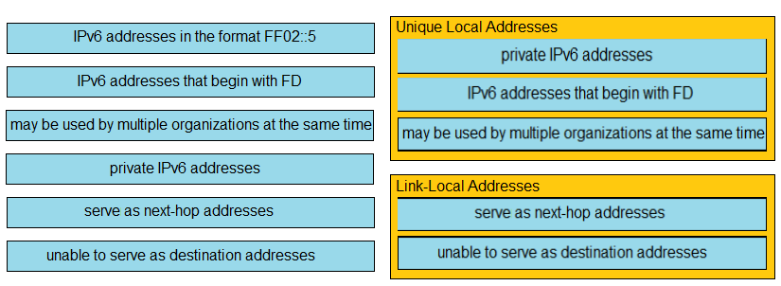

Question 138 ( Single Topic )

Which WAN topology has the highest degree of reliability?

* **A.**point-to-point
* **B.**router-on-a-stick
* **C.**full mesh
* **D.**hub-and-spoke

Answer : **C**

##### Question 139 ( Single Topic )

DRAG DROP -  
Drag and drop the IPv6 address type characteristics from the left to the right.  
Select and Place:

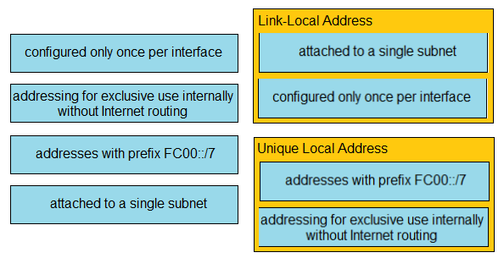

Question 140 ( Single Topic )

What causes a port to be placed in the err-disabled state?

* **A.**nothing plugged into the port
* **B.**link flapping
* **C.**latency
* **D.**shutdown command issued on the port

Answer : **B**

##### Question 141 ( Single Topic )

DRAG DROP -  
Drag and drop the characteristics of transport layer protocols from the left onto the corresponding protocols on the right.  
Select and Place

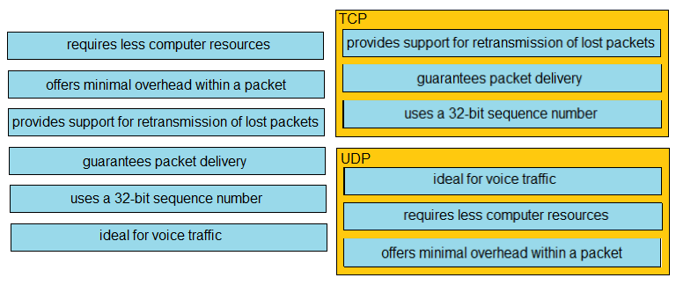

Question 142 ( Single Topic )

A network engineer must configure an interface with IP address 10.10.10.145 and a subnet mask equivalent to 11111111.11111111.11111111.11111000. Which subnet mask must the engineer use?

* **A.**/29
* **B.**/30
* **C.**/27
* **D.**/28

Answer : **A**

Question 143 ( Single Topic )

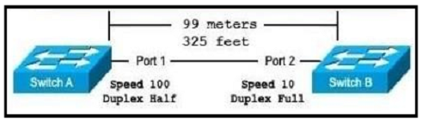  
Refer to the exhibit. The switches are connected via a Cat5 Ethernet cable that is tested successfully. The interfaces are configured as access ports and are both in a down status. What is the cause of the issue?

* **A.**The speed settings on the switches are mismatched
* **B.**The distance between the two switches is not supported by Cat5
* **C.**The switches are configured with incompatible duplex settings
* **D.**The portfast command is missing from the configuration
* Answer : **A**

Question 145 ( Single Topic )

The address block 192.168.32.0/24 must be subnetted into smaller networks. The engineer must meet these requirements:  
✑ Create 8 new subnets.  
✑ Each subnet must accommodate 30 hosts.  
✑ Interface VLAN 10 must use the last usable IP in the first new subnet.  
✑ A Layer 3 interface is used.  
Which configuration must be applied to the interface?

* **A.**no switchport mode trunk ip address 192.168.32.97 255.255.255.224
* **B.**switchport ip address 192.168.32.65 255.255.255.240
* **C.**no switchport ip address 192.168.32.30 255.255.255.224
* **D.**no switchport mode access ip address 192.168.32.62 255.255.255.240

Answer : **C**

##### Question 146 ( Single Topic )

DRAG DROP -  
Drag and drop the TCP or UDP details from the left onto their corresponding protocols on the right.  
Select and Place:

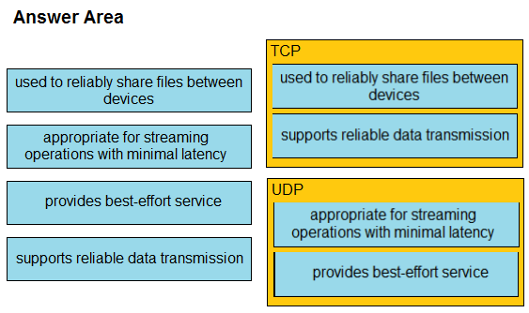

Question 147 ( Single Topic )

What are two reasons to deploy private addressing on a network? (Choose two.)

* **A.**to subnet addresses in an organized hierarchy
* **B.**to reduce network maintenance costs
* **C.**to segment local IP addresses from the global routing table
* **D.**to hide sensitive data from access users within an enterprise
* **E.**to route protected data securely via an Internet service provider

Answer : **AC**

##### Question 148 ( Single Topic )

DRAG DROP -  
Drag and drop the IPv6 DNS record types from the left onto the description on the right.  
Select and Place:

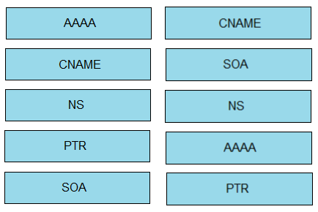

Question 149 ( Single Topic )

Which property is shared by 10GBase-SR and 10GBase-LR interfaces?

* **A.**Both use the single-mode fiber type.
* **B.**Both require UTP cable media for transmission.
* **C.**Both require fiber cable media for transmission.
* **D.**Both use the multimode fiber type.

Answer : **C**

##### Question 150 ( Single Topic )

DRAG DROP -  
Drag and drop the IPv6 addresses from the left onto the corresponding address types on the right.  
Select and Place:

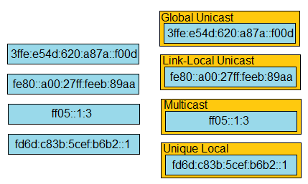

Question 151 ( Single Topic )

Which device permits or denies network traffic based on a set of rules?

* **A.**switch
* **B.**firewall
* **C.**wireless controller
* **D.**access point

Answer : **B**

Question 152 ( Single Topic )

What is the role of a firewall in an enterprise network?

* **A.**determines which packets are allowed to cross from unsecured to secured networks
* **B.**processes unauthorized packets and allows passage to less secure segments of the network
* **C.**forwards packets based on stateless packet inspection
* **D.**explicitly denies all packets from entering an administrative domain

Answer : **A**

##### Question 154 ( Single Topic )

DRAG DROP -  
Drag and drop the DNS lookup components from the left onto the functions on the right.  
Select and Place:

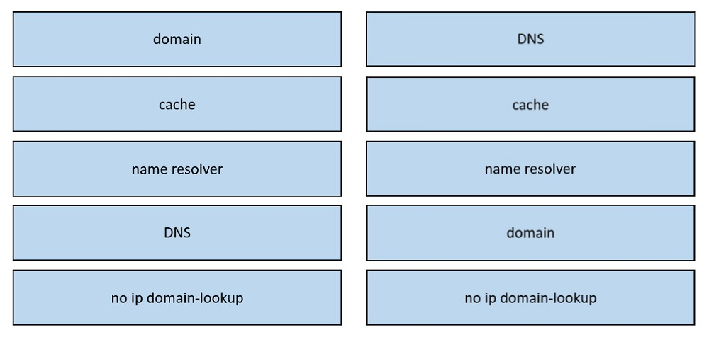

##### Question 155 ( Single Topic )

DRAG DROP -  
Drag and drop the TCP or UDP details from the left onto their corresponding protocols on the right.  
Select and Place:

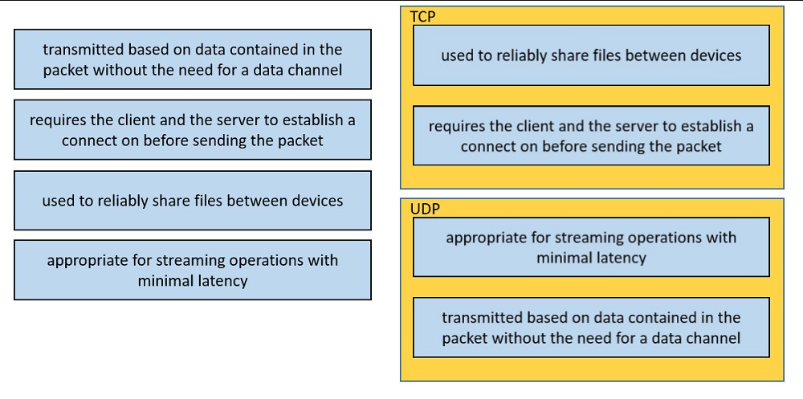

Question 157 ( Single Topic )

Which action is taken by a switch port enabled for PoE power classification override?

* **A.**As power usage on a PoE switch port is checked data flow to the connected device is temporarily paused
* **B.**When a powered device begins drawing power from a PoE switch port, a syslog message is generated
* **C.**If a switch determines that a device is using less than the minimum configured power, it assumes the device has failed and disconnects it
* **D.**Should a monitored port exceed the maximum administrative value for power, the port is shut down and err-disabled

Answer : **D**

Question 158 ( Single Topic )

What is a function spine-and-leaf architecture?

* **A.**Offers predictable latency of the traffic path between end devices.
* **B.**Exclusively sends multicast traffic between servers that are directly connected to the spine.
* **C.**Mitigates oversubscription by adding a layer of leaf switches.
* **D.**Limits payload size of traffic within the leaf layer.

Answer : **A**

Question 159 ( Single Topic )

Which action is taken by the data plane within a network device?

* **A.**Constructs a routing table based on a routing protocol.
* **B.**Forwards traffic to the next hop.
* **C.**Looks up an egress interface in the forwarding information base.
* **D.**Provides CLI access to the network device.

Answer : **B**

Question 160 ( Single Topic )

What is the function of the control plane?

* **A.**It exchanges routing table information.
* **B.**It provides CLI access to the network device.
* **C.**It looks up an egress interface in the forwarding information base.
* **D.**It forwards traffic to the next hop.

Answer : **A**

Question 161 ( Single Topic )

Which two cable types must be used to connect an access point to the WLC when 2.5-Gbps and 5-Gbps upload speeds are required? (Choose two.)

* **A.**10GBASE-T
* **B.**1000BASE-LX/LH
* **C.**Cat 5e
* **D.**Cat 5
* **E.**Cat 3

Answer : **AC**

Question 162 ( Single Topic )

What is a benefit for external users who consume public cloud resources?

* **A.**Implemented over a dedicated WAN
* **B.**All hosted on physical servers
* **C.**Accessed over the Internet
* **D.**Located in the same data center as the users

Answer : **C**

Question 163 ( Single Topic )

An engineer must update the configuration on two PCs in two different subnets to communicate locally with each other. One PC is configured with IP address  
192.168.25.128/25 and the other with 192.168.25.100/25. Which network mask must the engineer configure on both PCs to enable the communication?

* **A.**255.255.255.248
* **B.**255.255.255.224
* **C.**255.255.255.0
* **D.**255.255.255.252

Answer : **C**

Question 164 ( Single Topic )

Which key function is provided by the data plane?

* **A.**Originating packets
* **B.**Exchanging routing table data
* **C.**Making routing decisions
* **D.**Forwarding traffic to the next hop

Answer : **D**

Question 165 ( Single Topic )

When should an engineer implement a collapsed-core architecture?

* **A.**Only when using VSS technology
* **B.**For small networks with minimal need for growth
* **C.**For large networks that are connected to multiple remote sites
* **D.**The access and distribution layers must be on the same device

Answer : **B**

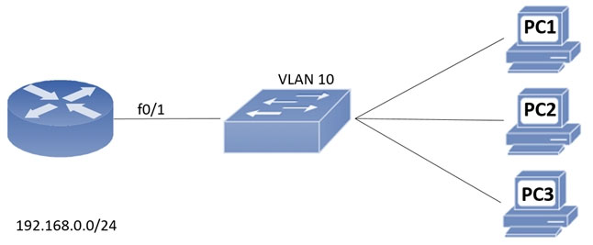  
Refer to the exhibit. An engineer assigns IP addressing to the current VLAN with three PCs. The configuration must also account for the expansion of 30 additional  
VLANS using the same Class C subnet for subnetting and host count. Which command set fulfills the request while reserving address space for the expected growth?

* **A.**Switch(config)#interface vlan 10 Switch(config-if)#ip address 192.168.0.1 265 255.255.252
* **B.**Switch(config)#interface vlan 10 Switch(config-if)#ip address 192.168.0.1 255 255.255.248
* **C.**Switch(config)#interface vlan 10 Switch(config-if)#ip address 192.168.0.1 255 255.255.0
* **D.**Switch(config)#interface vlan 10 Switch(config-if)#ip address 192.168.0.1 255.255.255.128

Answer : **B**

Question 167 ( Single Topic )

A client experiences slow throughput from a server that is directly connected to the core switch in a data center. A network engineer finds minimal latency on connections to the server, but data transfers are unreliable, and the output of the show interfaces counters errors command shows a high FCS-Err count on the interface that is connected to the server. What is the cause of the throughput issue?

* **A.**a physical cable fault
* **B.**a speed mismatch
* **C.**high bandwidth usage
* **D.**a cable that is too long

Answer : **A**

Question 168 ( Single Topic )

What is the difference between 1000BASE-LX/LH and 1000BASE-ZX interfaces?

* **A.**1000BASE-LX/LH interoperates with multimode and single-mode fiber, and 1000BASE-ZX needs a conditioning patch cable with multimode.
* **B.**1000BASE-ZX interoperates with dual-rate 100M/1G 10Km SFP over multimode fiber, and 1000BASE-LX/LH supports only single-rate
* **C.**1000BASE-ZX is supported on links up to 1000km, and 1000BASE-LX/LH operates over links up to 70 km
* **D.**1000BASE- LX/LH is supported on links up to 10km, and 1000Base-ZX operates over links up to 70 km

Answer : **D**

Question 169 ( Single Topic )

What are two reasons to implement IPv4 private addressing on a network? (Choose two.)

* **A.**To enable internal applications to treat the private IPv4 addresses as unique
* **B.**To facilitate renumbering when merging networks
* **C.**To expand the routing table on the router
* **D.**To provide protection from external denial-of-service attacks
* **E.**To conserve global unique IPv4 addresses

Answer : **DE**

Question 170 ( Single Topic )

Which concern is addressed with the use of private IPv4 addressing?

* **A.**Lack of routing protocol support for CIDR and VLSM
* **B.**Lack of security protocols at the network perimeter
* **C.**Lack of available TCP/UDP ports per IPv5 address
* **D.**Lack of available publicly routable unique IPv4 address

Answer : **D**

Question 171 ( Single Topic )

What is the path for traffic sent from one user workstation to another workstation on a separate switch in a three-tier architecture model?

* **A.**access ג€" core ג€" access
* **B.**access ג€" distribution ג€" distribution ג€" access
* **C.**access ג€" core ג€" distribution ג€" access
* **D.**access ג€" distribution ג€" core ג€" distribution ג€" access

Answer : **D**

Question 172 ( Single Topic )

What is the difference between IPv6 unicast and anycast addressing?

* **A.**An individual IPv6 unicast address is supported on a single interface on one node, but an IPv6 anycast address is assigned to a group of interfaces on multiple nodes.
* **B.**IPv6 anycast nodes must be explicitly configured to recognize the anycast address, but IPv6 unicast nodes require no special configuration.
* **C.**IPv6 unicast nodes must be explicitly configured to recognize the unicast address, but IPv6 anycast nodes require no special configuration.
* **D.**Unlike an IPv6 anycast address, an IPv6 unicast address is assigned to a group of interfaces on multiple nodes.

Answer : **A**

Question 174 ( Single Topic )

Which WAN topology provides a combination of simplicity quality, and availability?

* **A.**partial mesh
* **B.**full mesh
* **C.**point-to-point
* **D.**hub-and-spoke

Answer : **C**

##### Question 175 ( Single Topic )

DRAG DROP -  
Drag and drop the statements about wireless architectures from the left onto the architectures on the right.  
Select and Place:

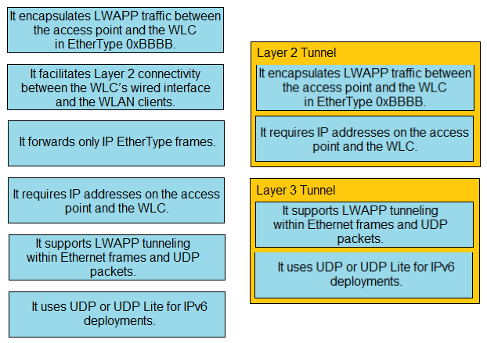

##### Question 176 ( Single Topic )

DRAG DROP -  
Drag and drop the Wi-Fi terms from the left onto the descriptions on the right.  
Select and Place:

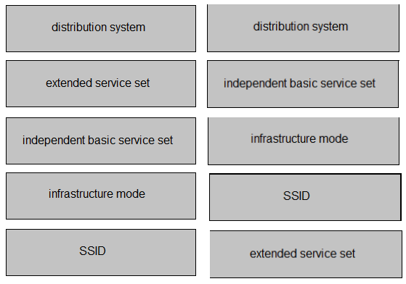

Question 177 ( Single Topic )

How are the switches in a spine-and-leaf topology interconnected?

* **A.**Each leaf switch is connected to one of the spine switches
* **B.**Each leaf switch is connected to each spine switch.
* **C.**Each leaf switch is connected to two spine switches, making a loop.
* **D.**Each leaf switch is connected to a central leaf switch, then uplinked to a core spine switch.

Answer : **B**

Question 178 ( Single Topic )

What is the primary effect of the spanning-tree portfast command?

* **A.**It immediately enables the port in the listening state.
* **B.**It immediately puts the port into the forwarding state when the switch is reloaded.
* **C.**It enables BPDU messages.
* **D.**It minimizes spanning-tree convergence time.

Answer : **D**

Question 179 ( Single Topic )

What occurs when PortFast is enabled on an interface that is connected to another switch?

* **A.**Root port choice and spanning-tree recalculation are accelerated when a switch link goes down.
* **B.**After spanning-tree converges, PortFast shuts down any port that receives BPDUs.
* **C.**VTP is allowed to propagate VLAN configuration information from switch to switch automatically.
* **D.**Spanning-tree fails to detect a switching loop increasing the likelihood of broadcast storms.

Answer : **D**

Question 180 ( Single Topic )

Which QoS Profile is selected in the GUI when configuring a voice over WLAN deployment?

* **A.**Platinum
* **B.**Bronze
* **C.**Gold
* **D.**Silver

Answer : **A**